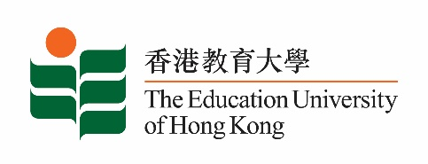
致： 传媒机构采访主任 5 May 2023
To : News Editors

香港教育大学2023年 5月8日至 21日可供采访之活动一览
The Education University of Hong Kong (EdUHK) Events Calendar for 8 - 21 May 2023
本校诚邀 贵机构派员采访下列活动。传媒查询，请联络教大传讯处（电话：2948 6050）。
You are cordially invited to cover the events below. For media enquiries, please contact the Communications Office at 2948 6050.

以下活动或有人数限制，传媒请预先向主办部门登记。
There may be restrictions on the number of participants for the following event(s). Please contact the respective organiser(s) / department(s) for prior registration.

- 教大大埔校园 （新界大埔露屏路十号） / EdUHK Tai Po Campus (10 Lo Ping Road, Tai Po, New Territories)

日期  Date | 时间  Time | 活动  Event | 地点  Venue | 主办部门及公众查询  Organiser &  Public Enquiry | 备注  Remarks
2023-05-08 | 2 pm – 3:15 pm | Music Ensemble Concert | 教大大埔校园  C-LP-11  C-LP-11,  EdUHK Tai Po Campus | 主办部门 / Organiser:  文化与创意艺术学系  Department of Cultural and Creative Arts  查询 / Enquiries:  Dr Lo Khin Yee  电话 / Tel:  2948 7259 | 免费入场，  欢迎各界人士参加。Free admission.  All are welcome.
2023-05-16 | 2:30 pm – 5 pm | 粤港澳大湾区基层理财教育研讨会  The Symposium of Financial Education for Vulnerable Group in Greater Bay Area  嘉宾 / Guest :  香港小区组织协会副主任 施丽珊女士  Ms Sze Lai-shan  Deputy Director,  Society for Community Organization  姚伟梅教授  Professor Christina Yu Wai -mui | 教大大埔校园  D4-1/F-20  D4-1/F-20  EdUHK Tai Po Campus | 主办部门 / Organiser:  社会科学系  Department of Social Sciences  查询 / Enquiries:  谭伟强博士 Dr Tan Weiqiang  电话 / Tel:  2948 8540 | 免费入场，  欢迎各界人士参加。Free admission.  All are welcome.

